

**DISTINCT**

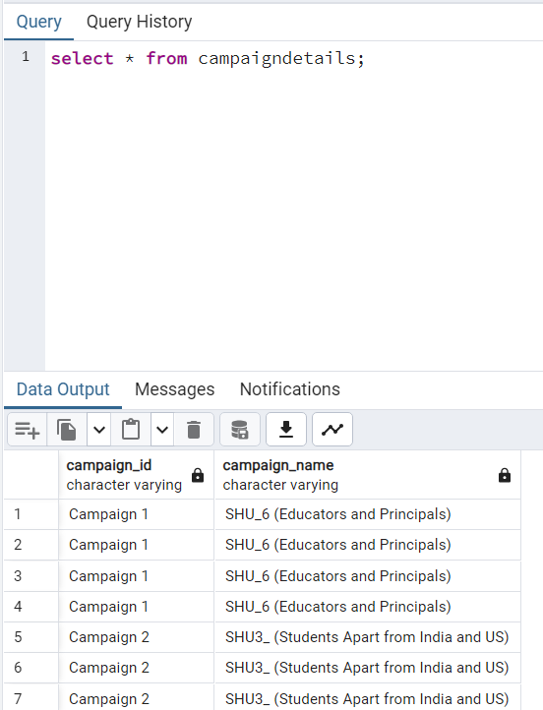

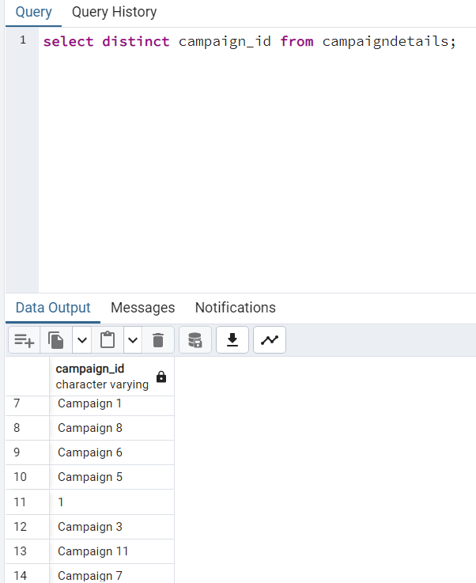

**COUNT**

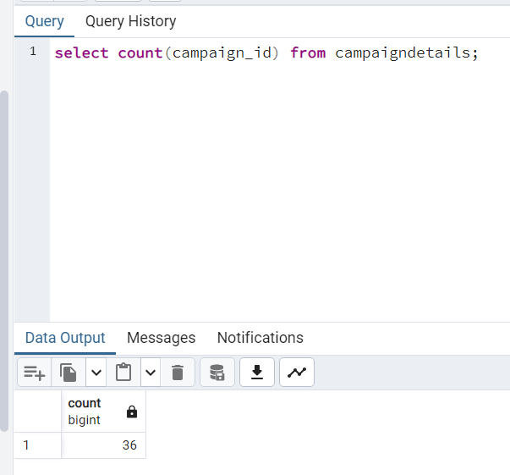

**LIMIT**

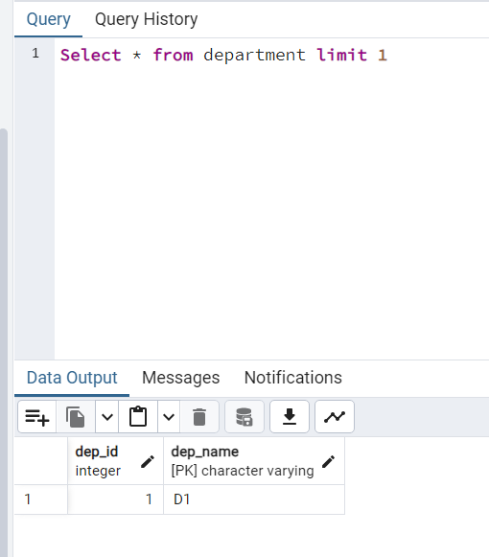

**Combination of limit with order by**

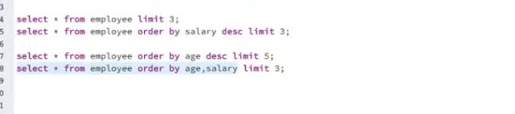

**COUNT OF DISTINCT VALUES**

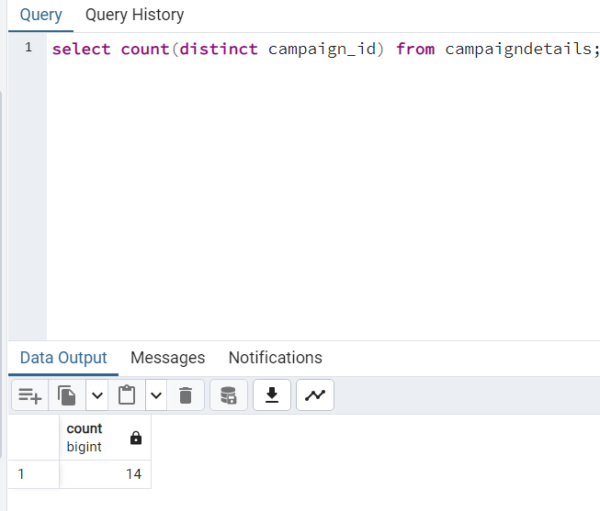

**AS**

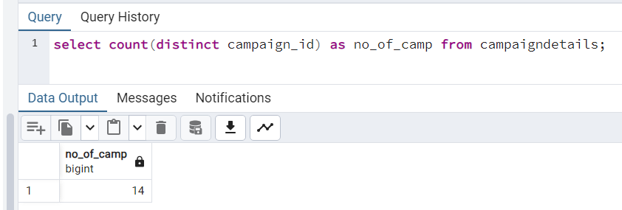

**ORDER BY**

Default order id ascending

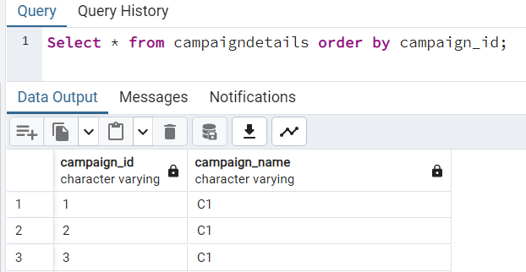

Order by in descending

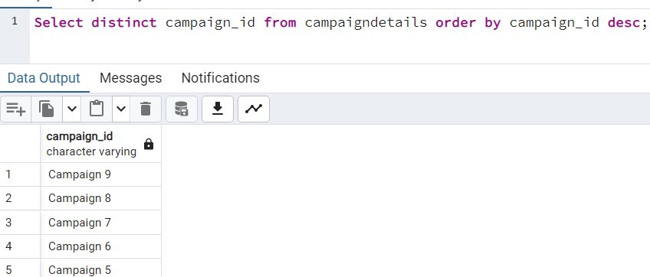

When more than one order by columns are give the second column will takes when some of the duplicate values are there in column one

In the below example we have duplicate age in age column so the salary of those person are getting sorted in ascending.

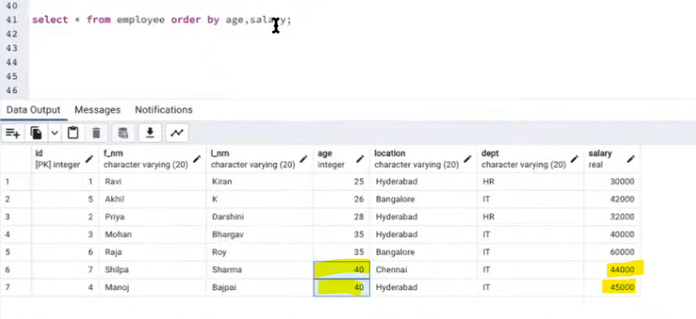

Without specification of second attribute in order by than the column salary is in default order

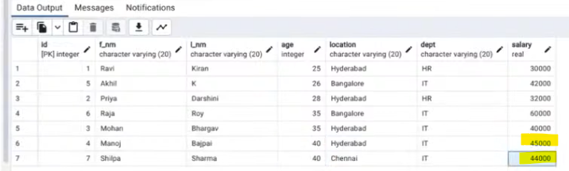

**OFFSET**

It is index of row, helps to specify the starting point of the data fetched, offset are starts from 0 in db

EX:

Lets say we want 3 data from index 33 that is below, that can be done by offset

